Overview

The Delmarva Foundation for Medical Care’s (DFMC) Baltimore City “Using Data to Drive Improvement’ Special Innovation Project (SIP) aims to improve patient outcomes for Medicare and Medicare/ Medicaid beneficiaries with serious chronic illness and those diagnosed with Diabetes, Chronic Obstructive Pulmonary Disease, Congestive Heart Failure, and Chronic Kidney Disease. To achieve this goal, DFMC, in partnership with the Baltimore City Health Department and a variety of local businesses, public health and healthcare organizations, community activists, and most importantly Baltimore senior citizens, will focus on improving programming for nutrition, physical activity, and health screenings through a “one-stop shop” model at a senior residence and a senior center. These programs will run at a pre-designated time each week, with a variety of opportunities for seniors to participate in. Both senior facility residents/users and staff at senior facilities will ensure that programming meets their wants and needs in an effective, efficient, and culturally appropriate manner.

Approach

To target the two selected communities, we are setting up community hubs in one senior center and one senior housing complex, a citywide communications strategy, and a governance structure.

- Community hubs: Through the leadership of the Baltimore City Health Department, as well as a variety of other public health and healthcare groups, these two sites will have “one-stop shops” for seniors at a pre-designated time each week.

These hubs will be focused on:
- Nutritional needs
  - Education on healthy foods/diets
  - Partner programs
  - Healthy habits, including lifestyle
- What insurance benefits and related benefits programs seniors are eligible for (e.g., Medicare Part D)

Seniors will have a variety of on-site, direct services, which could include:
- Virtual Supermarket Program (online grocery delivery)
- SNAP and QIMBY registration and assistance
- Basic health screenings
- On-site dietician
- Medicine reconciliation
- Small-scale farmers market
- Insurance assistance
- LIGHT (energy/housing assistance)

The program could also include sign-up opportunities for a variety of other programs, including:
- Grocery Store Shuttle (via Santoni’s)
- Neighborhood Food Advocates
- Exercise Classes (Line dancing, Aqua Aerobics, Medical Mile)
- Community Gardening opportunities

- Citywide Communication strategy: Though the project interventions are focused in two sites, our communications strategy will be citywide. The communications outreach will specifically focus around food deserts and alerting residents to a variety of opportunities in Baltimore to access and prepare healthy foods. This strategy will be aligned with the Baltimore City Health Department’s current communications strategy.

- Broader Governance Strategy: Sustainability beyond the scope of DFMC’s project is essential in order to see demonstrable improvement in the health outcomes. The project has been designed with the BCHD and the residents of Baltimore leading it, so that it can be carried on after the 12-month period.

Community

Both of the communities we selected these were identified both as “food desert” communities that have low life expectancies and high rates of mortality from diabetes, heart disease and stroke. For example, the areas we have targeted have life expectancies under 65 years of age. Additionally, through community meetings convened by the Baltimore City Health Department and the DFMC, residents indicated that food access, affordability and nutrition were some of the top priorities that needed addressing in their community.

Below is a map displaying the food desert community in Baltimore:

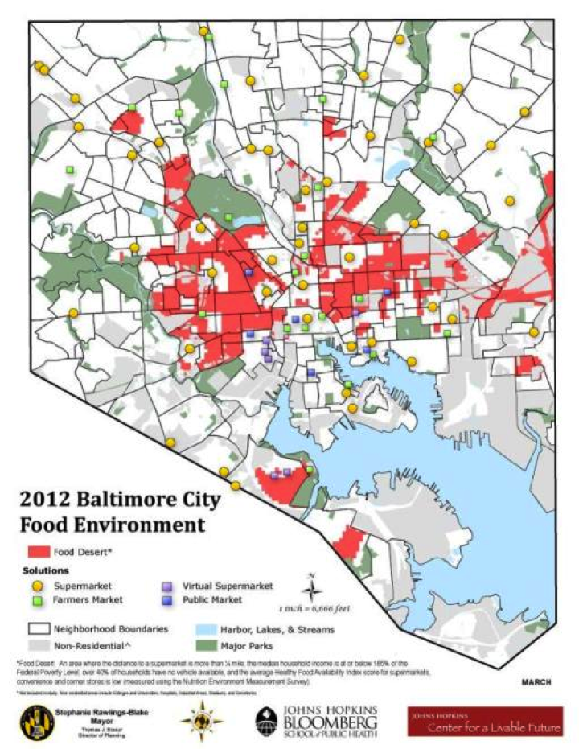

The map below shows life expectancy by community statistical area:

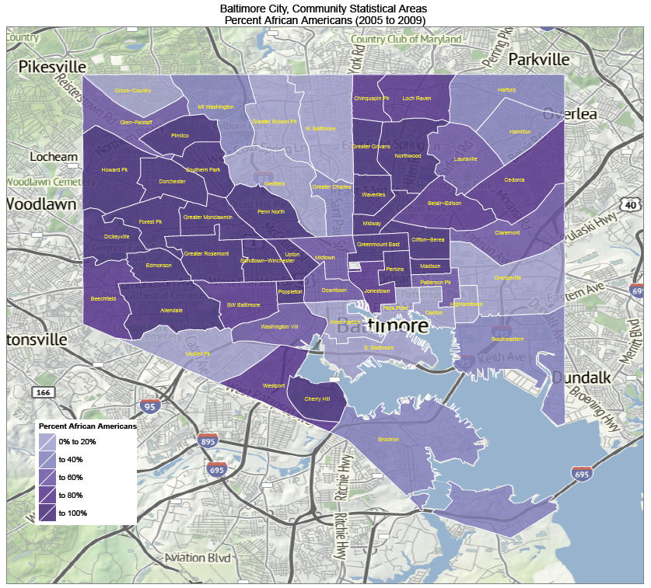

Care Providers in Baltimore

This map shows the hospitals in the Baltimore area:

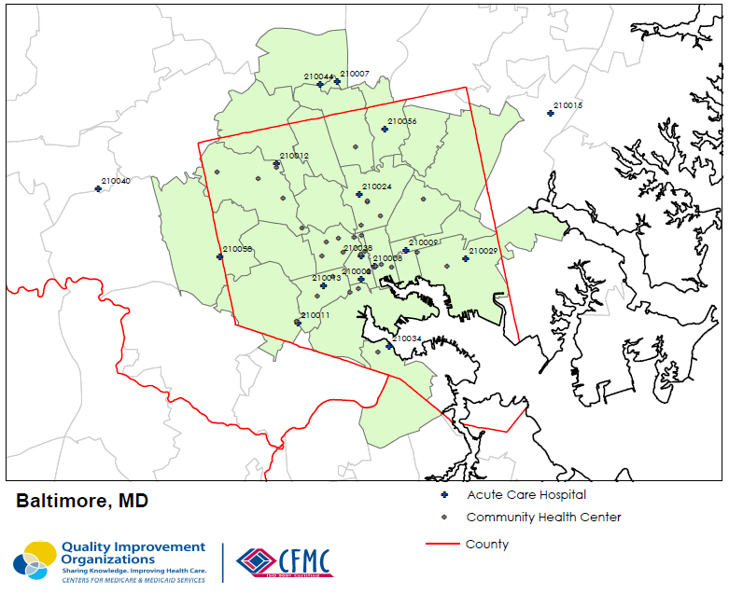

This map shows care providers across the city of Baltimore:

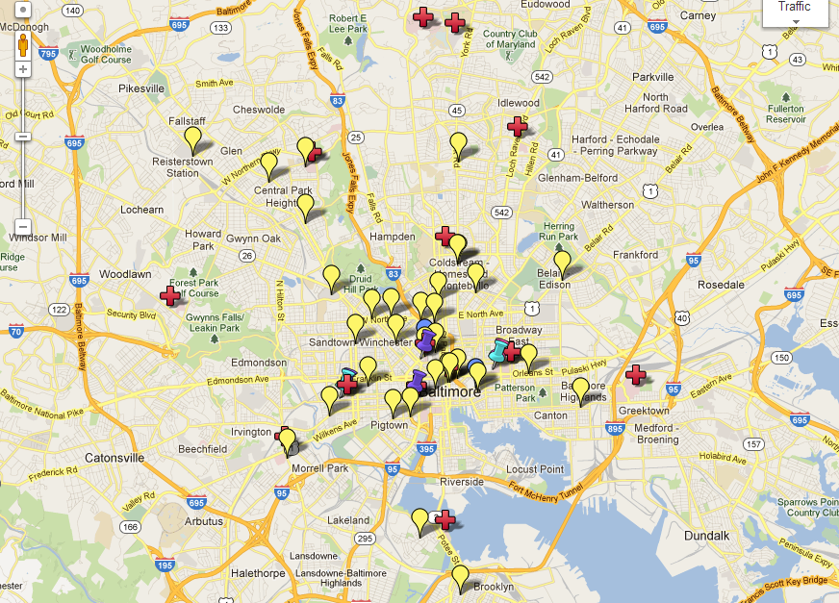

Figure 2. Baltimore City current initiatives (Red crosses: Hospitals; Yellow teardrops: Community Health Centers; Blue teardrops: City/State Health Departments; Pink thumbtack: Community advisory group; Light blue thumbtacks: Health Enterprise Zone application pending; Purple thumbtacks: Community-based Care Transitions program funding received)
